Week 5
Task 1
Implement a producer-consumer communication system using anonymous pipes where the parent process generates data and the child process consumes it. Measure the communication efficiency. Develop a program that executes the equivalent of the shell command: ls-1 | grep ".c" using fork(), pipe(), dup2(), and exec() system calls.
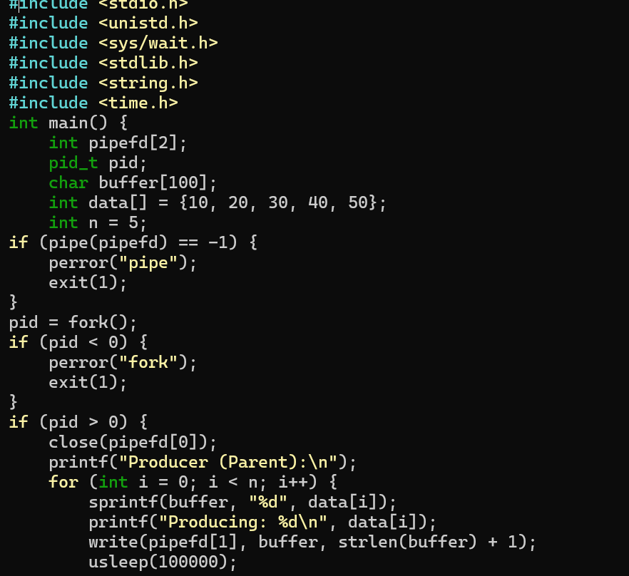

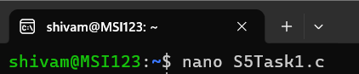

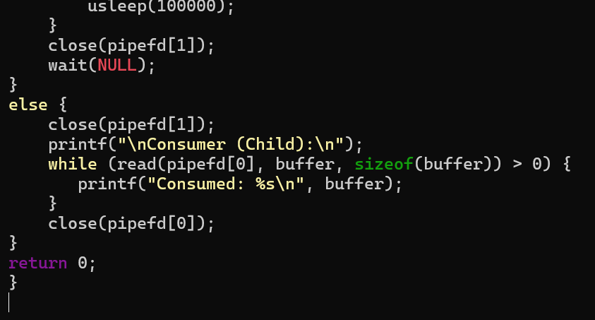
OUTPUT:
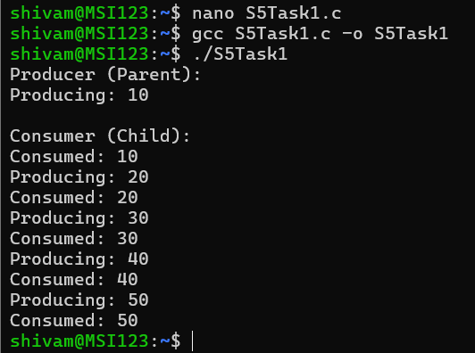

Task 2
Develop a program that executes the equivalent of the shell command: ls-1 | grep ".c" using fork(), pipe(), dup2(), and exec() system calls.
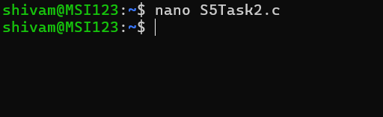

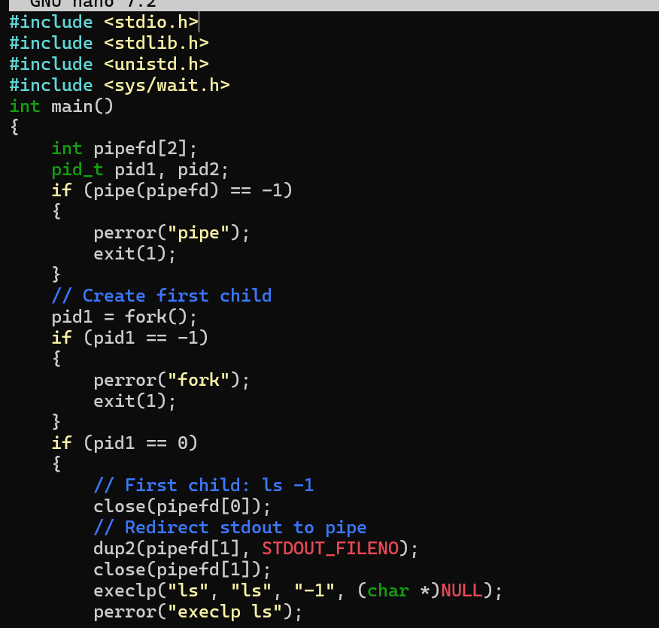

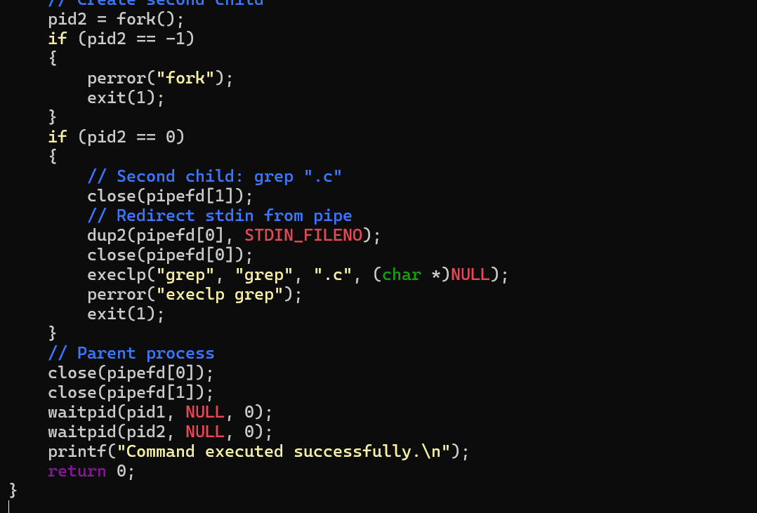

OUTPUT:

